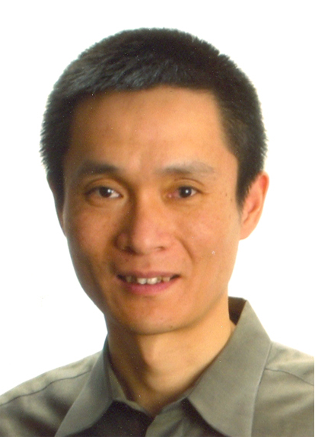
Chuan He, Ph.D., is a professor in the Department of Chemistry and Institute for Biophysical Dynamics at the University of Chicago, and a Cheung Kong Professor in the Department of Chemical Biology at Peking University. He received his B.S. (1994) from the University of Science and Technology of China and his Ph. D. degree from Massachusetts Institute of Technology in chemistry in 2000. After being trained as a Damon-Runyon postdoctoral fellow at Harvard University from 2000-2002, he joined the University of Chicago as an assistant professor in the Department of Chemistry and was promoted to full professor in 2010. He is also a member of the Institute for Biophysical Dynamics and Cancer Research Center at the University of Chicago. His research spans a broad range of chemistry, chemical biology, microbiology, biochemistry, structural biology and cell biology.

Nucleic Acids Modification/Demodification and Probes for Live Cell Imaging

Chuan He
Department of Chemistry, University of Chicago, 929 East 57th Street, Chicago, IL, 60637, USA
Reversible chemical modifications on nucleic acids and proteins determine cell fates. The five bases that comprise nucleic acids ─ adenine, guanine, cytosine, thymine, and uracil ─ can be chemically and enzymatically modified. These chemical events can have significant biological consequences, particularly for gene expression. I will present chemical strategies we have developed to enrich and sequence novel nucleic acid modifications in mammalian genome.¹ Several AlkB family proteins have been identified in the human genome that may mediate nucleic acids oxidation. Some of these proteins play critical roles in obesity/diabetes and various cancers. I will present our recent results that reveal the exact nucleic acid substrates and cellular function of some of these intriguing enzymes.² Based on these discoveries we propose a new mode of biological regulation that depends on reversible RNA modification, for which we termed “RNA Epigenetics”.³ In the second part, I will discuss our efforts to develop genetically encoded or small molecule-based probes for live cell imaging of metal ions and hydrogen sulfide.⁴

1. Song, C.-X.; Szulwach, K. E.; Fu, Y.; Dai, Q.; Yi, C.; Li, X.; Chen, C.-H.; Zhang, W.; Jian, X.; Wang, J.; Zhang, L.; Looney, T. J.; Zhang, B.; Godley, L. A.; Hicks, L. M.; Lahn, B. T.; Jin, P.* and He, C*. “Selective chemical labeling reveals the genome-wide distribution of 5-hydroxymethylcytosine” Nature Biotechnol. 2011, 29, 68-72.
2. Yi, C.; Jia, G; Hou, G.; Dai, Q.; Zhang, W.; Zheng, G.; Jian, X.; Yang, C.-G.; Cui, Q. and He, C.; "Iron-catalysed oxidation intermediates captured in a DNA repair dioxygenase" Nature 2010, 468, 330-333.
3. He, C.; "Grand Challenge Commentary: RNA epigenetics?" Nature Chem. Biol. 2010, 6, 863.
4. Wegner, S.; Arslan, H.; Sunbul, M.; Yin, J; He, C. "Dynamic Copper(I) Imaging in Mammalian Cells with a Genetically Encoded Fluorescent Copper(I) Sensor" J. Am. Chem. Soc. 2010, 132, 2567-2569.

