In Situ Curable Polysiloxane Soft Gels:
A Revolutionary Solution to Presbyopia and Cataract Eye Diseases

Dr Xiaojuan Hao (xiaojuan.hao@csiro.au, +61 3 9545 2614)
CSIRO Materials Science and Engineering, Australia

ABSTRACT
People focus on close objects by changing the shape of the natural lens inside the eye. However, as we age the natural lens hardens and we gradually lose our ability to near focus (a condition known as presbyopia) and as a result most people eventually need reading glasses after 45 years old. This project aims to develop an artificial lens designed to restore the eye’s ability to near focus (restoration of accommodation). We have developed polysiloxane soft gels that can be injected into the capsular bag of the eye and crosslinked in situ (an injectable, in situ curable accommodating intraocular lens) to replace a hardened and/or cataractous natural crystalline lens which is no longer capable of accommodation. These materials are designed to mimic the optical and mechanical properties of a young person’s natural lens thus restoring accommodation of the aged eyes. Due to the fact that most of people lose their ability to near focus as they age, this medical device has potential to have a huge impact on improving the quality of human life worldwide.
This is an internationally collaborative project between Commonwealth Scientific and Industrial Research Organisation (CSIRO, Australia) and Vision Collaborative Research Centre (VCRC, UNSW, Sydney), Bascom Palmer Eye Institute (University of Miami, USA), and LV Prasad Eye Institute (Hyderabad, India).

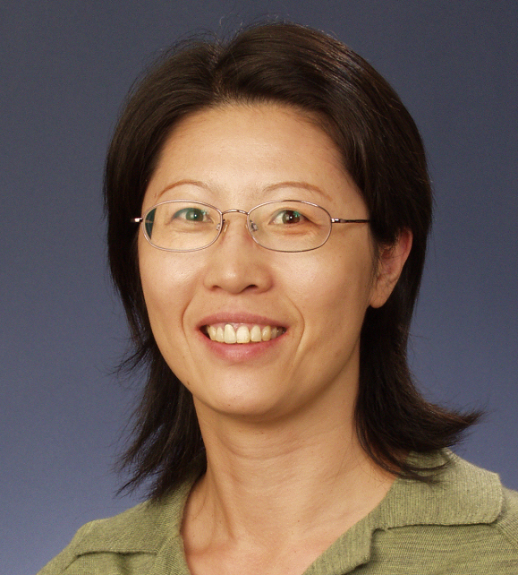
About the speaker
Dr Xiaojuan Hao received her PhD from the University of New England, Australia, in 2001. She did her first Post Doctoral fellowship at the University of Melbourne with Professor David Solomon. She worked on polyacrylamide hydrogels for protein separation, a technology that was later commercialised by the establishment of a new company, Gradipore. Dr Hao then moved to University of New South Wales to work with Professor Tom Davis on RAFT chemistry. During this time she designed and prepared a range of functional polymers of different architectures via RAFT free radical polymerisation, including a variety of block polymers, star polymers, and core-shell structured nano to micro particles. In 2006, she joined the Biomaterials group at CSIRO Molecular and Health Technologies as a research Scientist. She currently works on a variety of biomaterials, including ophthalmic materials, drug delivery systems, and functionalised carbon nanotubes for medical imaging contrast agents, etc. Her research interests include the design and synthesis of macromolecules particularly for biomedical applications.

